Basics

Adding a new page:
- Click on the plus button in the left panel under the “Pages” Section
- Click on New Page
- A blank new page will be created
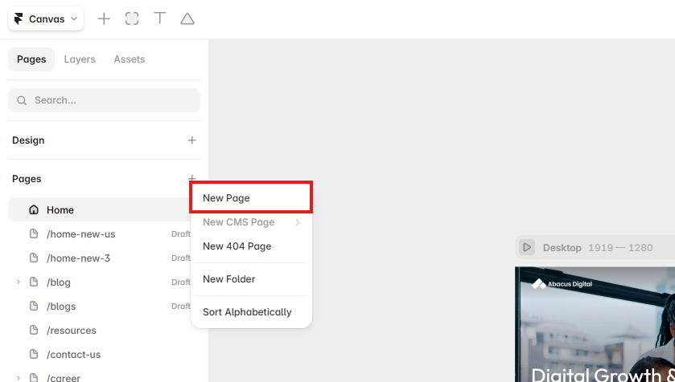

Renaming a page
- Hover over the page in the left panel under the “Pages” section
- Double-click on the page name
- Enter the new page name and press Enter

Duplicating a page
- Hover over the page in the left panel under the “Pages” section
- Right-click on the page you want to duplicate
- Select “Duplicate” to create a copy of the page

Deleting a page
- Hover over the page in the left panel under the “Pages” section
- Right-click on the page you want to delete
- Select “Delete” to remove the page

Changing a page URL
- Hover over the page in the left panel under the “Pages” section
- Right-click on the page and Select settings
- On the right side you will find the option to change the URL
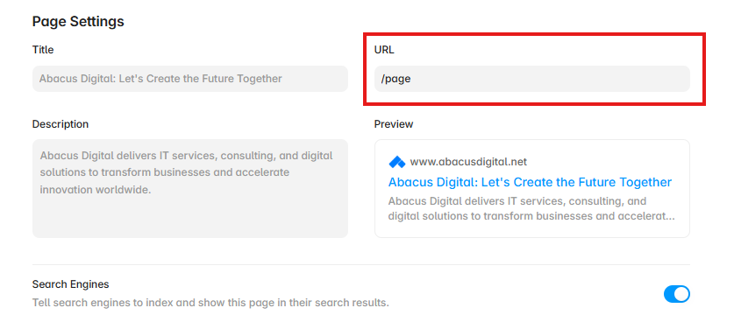

Adding a Path / Subfolder Page or Converting an existing page to Path / Subfolder
- Hover over the page in the left panel under the “Pages” section
- Right-click on the page
- Select settings
- On the right side you will find the option to change the URL to something like /example/sub-page-name
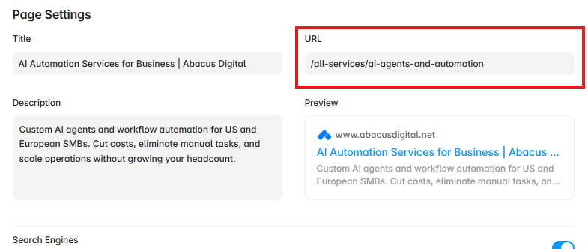
Or
- Rename the page like the exact same way /example/sub-page-name

Careers Page

Careers Page Structure
The Careers page contains an overview of all available job openings. Each individual job posting has its own sub-page containing the complete Job Description (JD), responsibilities, requirements, and application details.
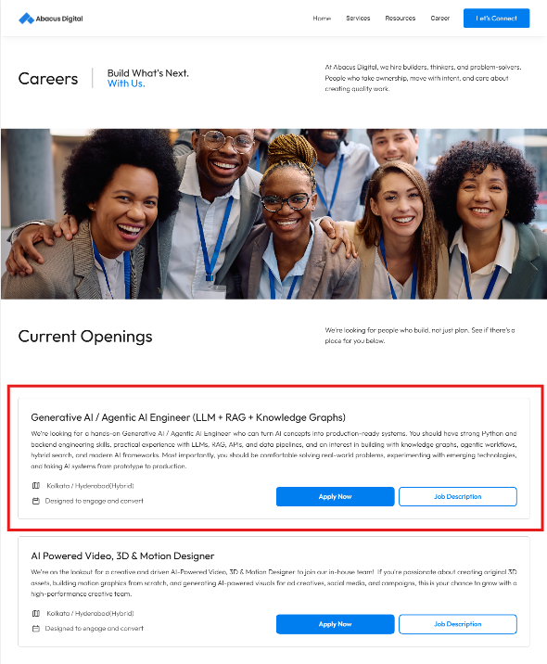
The job cards are separate card components which can be edited for the current job openings. When there are active job posts, these cards will be visible. In case of no job openings, a section with “No Jobs” will be visible and “Job Openings” should be hidden.
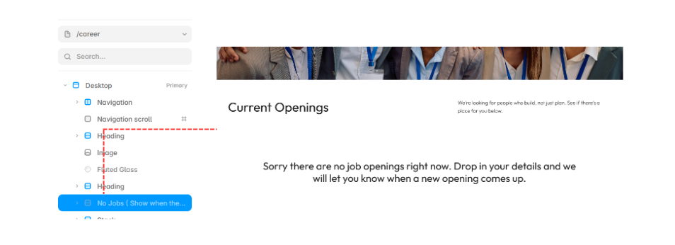

Job Post Page Structure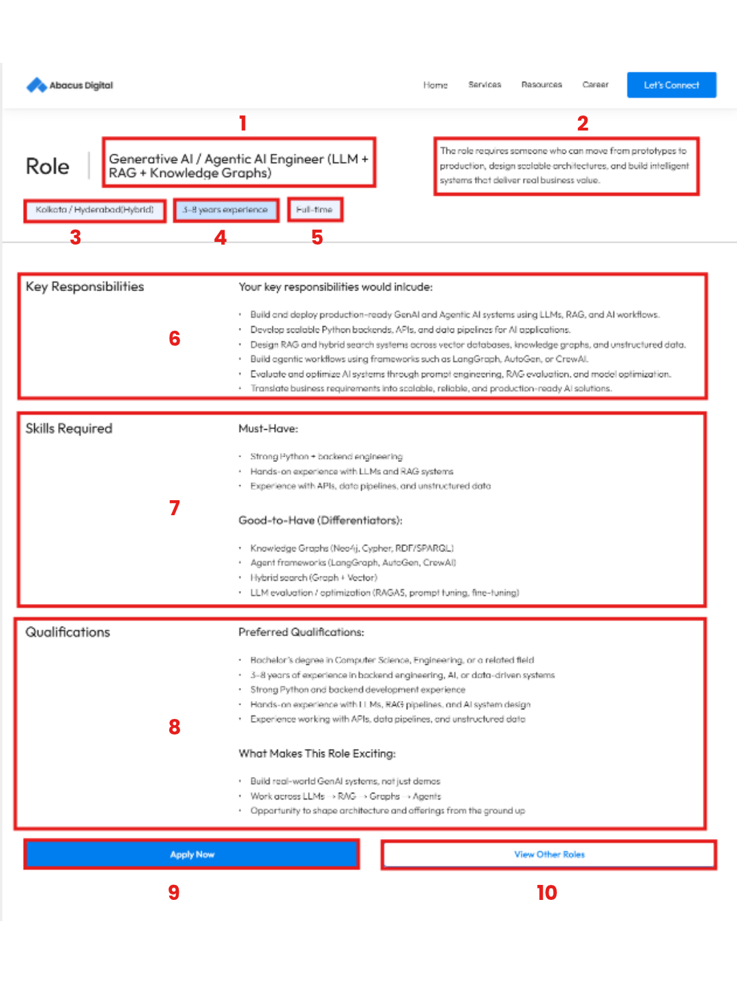
- Job Role: The exact role abacus is looking for.
- Description: Short description about the job role.
- Job location: The locations for the job post. Eg. Kolkata, Hyderabad, Hybrid, Remote…
- Experience: Total experience required for the job role.
- Type of job: Part-Time, Full-Time, Contractual…
- Key Responsibilities: Includes the scope of the job
- Skills Required: Includes the must haves and good to have skills
- Qualifications: Includes all the qualifications required for the job.
- Apply Now Button that links to the form.
- View Other Roles button that links to the main career page.
Currently, all job posts share a common google form hosted at https://forms.gle/9UqWs4TxHQ8tVBok8

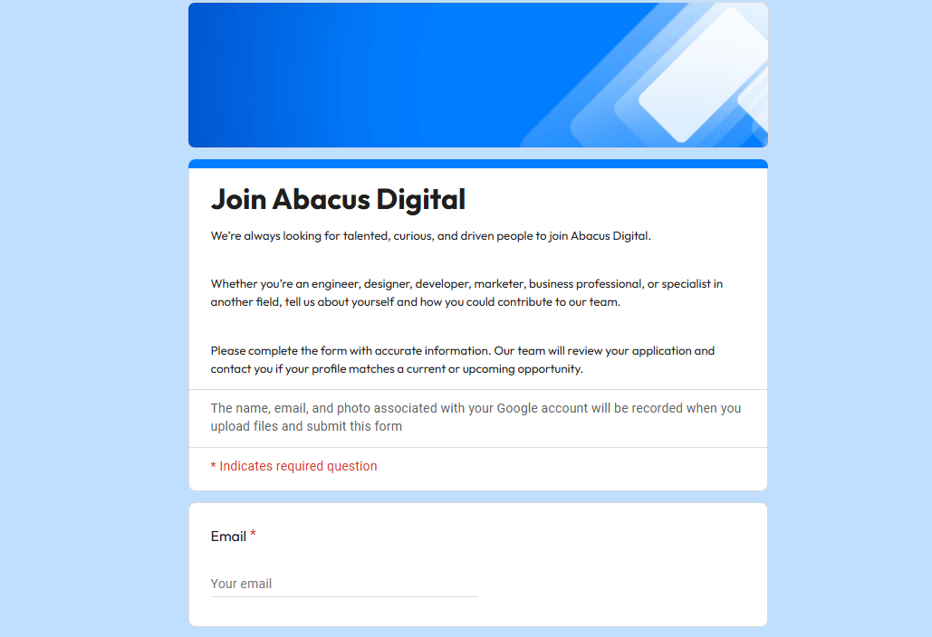
Edit access is with development.abacusdigital@gmail.com and the responses can be viewed by the same in the form responses section.
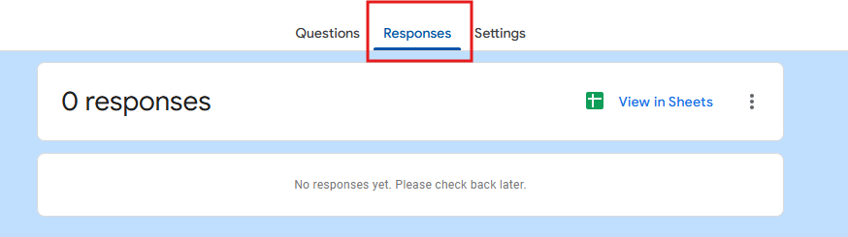

The same can be viewed here in this google sheet as well https://docs.google.com/spreadsheets/d/1cnfRzQLXMh5zU7cE8wg6CVcPSlKski1Lb6wERzqfGuE/edit?resourcekey=&gid=883429470#gid=883429470

info.abacusdigital@gmail.com has view access to this as well.

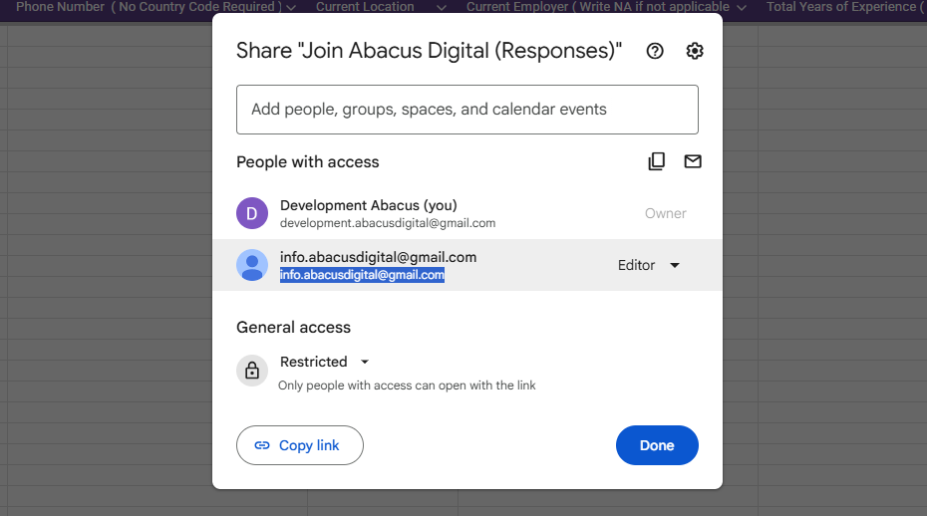

Adding a New Job Posting
- Open the existing job posting page that you want to use as a template.
- Right-click on the page in the left panel under the “Pages” section.
- Select “Duplicate” to create a copy of the existing job posting page.
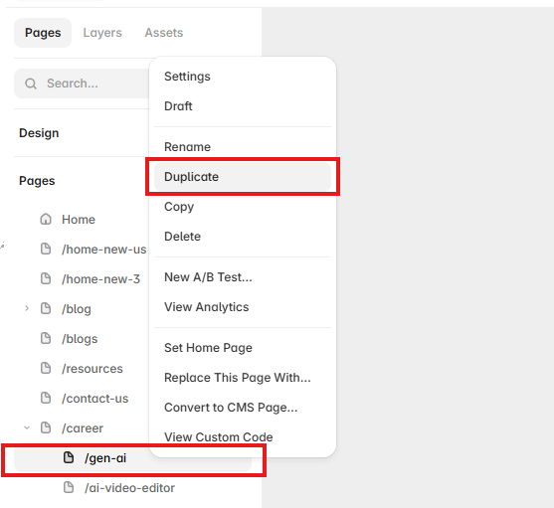

Updating the New Job Posting
- Open the duplicated page.
- Rename the page according to the new job title.
- Replace the existing job title, description, responsibilities, requirements, and other job-specific information.
- Review the page to ensure all content from the previous job posting has been replaced with the new information.
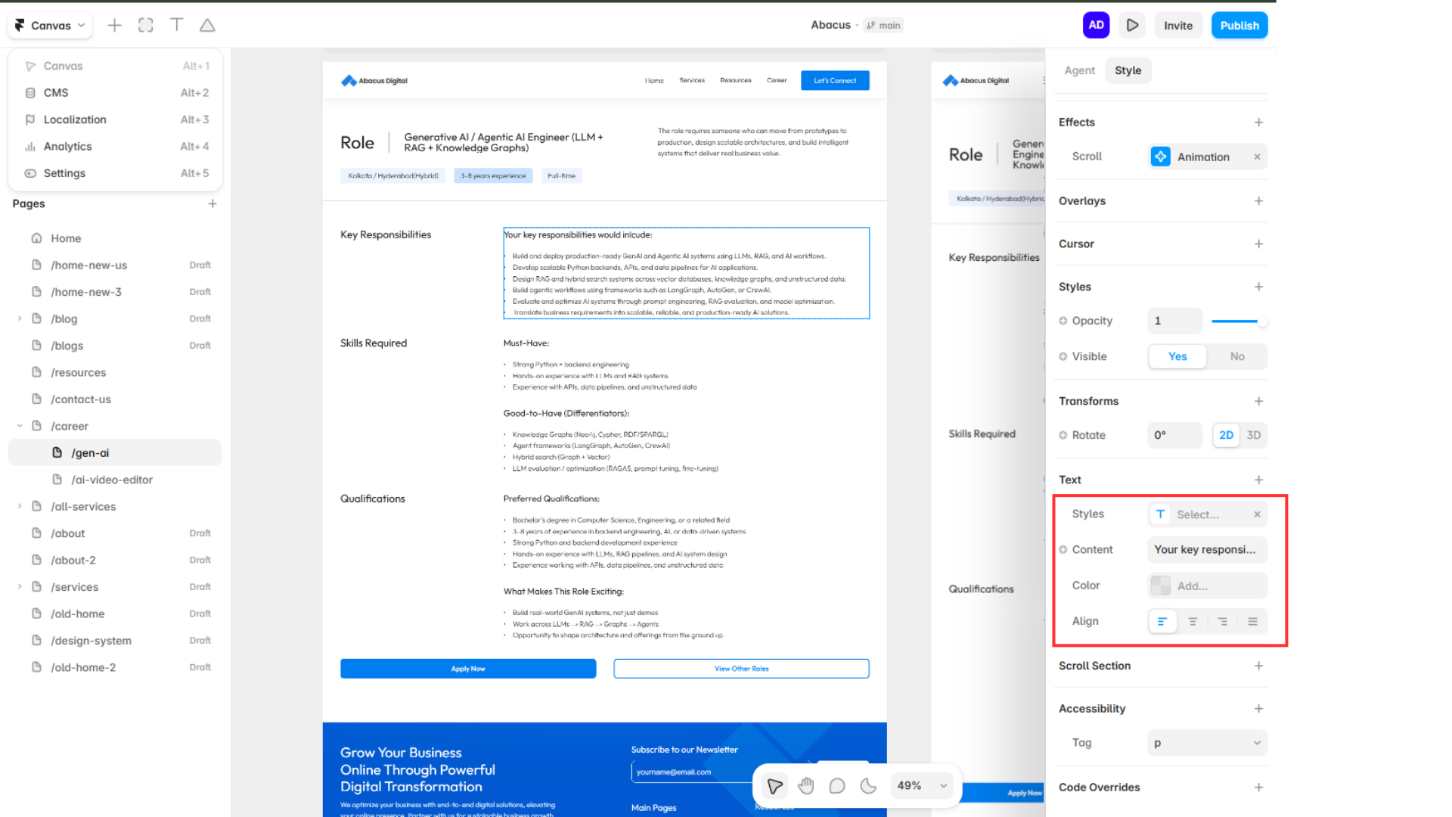
Double-click the text on the Canvas or use the Text Section in the Style panel to easily edit the content, style, color, and alignment.
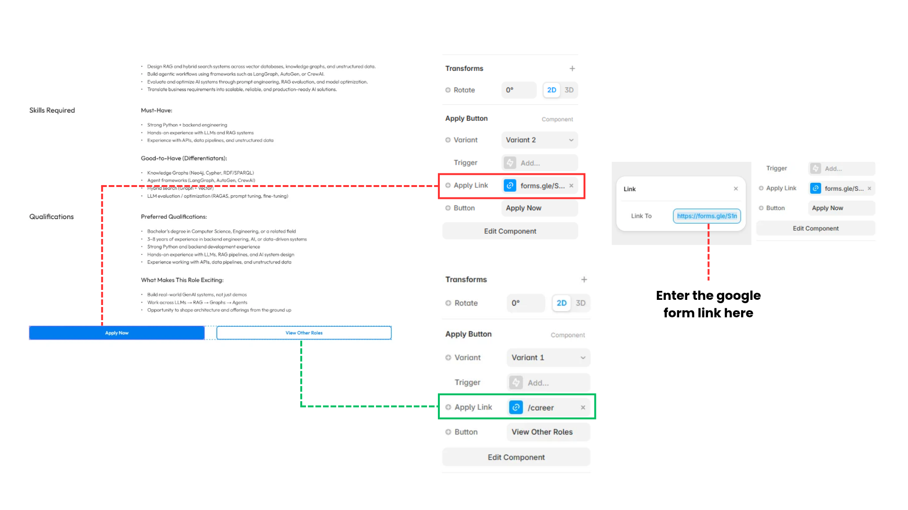

Updating an Existing Job Posting
- Open the relevant job posting sub-page from the “Pages” section.
- Update the required job information.
- Review the page for any outdated content or links.
- Publish the website to make the changes live.

Adding the New Job to the Careers Page
- Open the main “Careers” page.
- Duplicate an existing job card for the position.
- Update the job title and relevant information on the card.
- Link the job card to the newly created job posting sub-page.
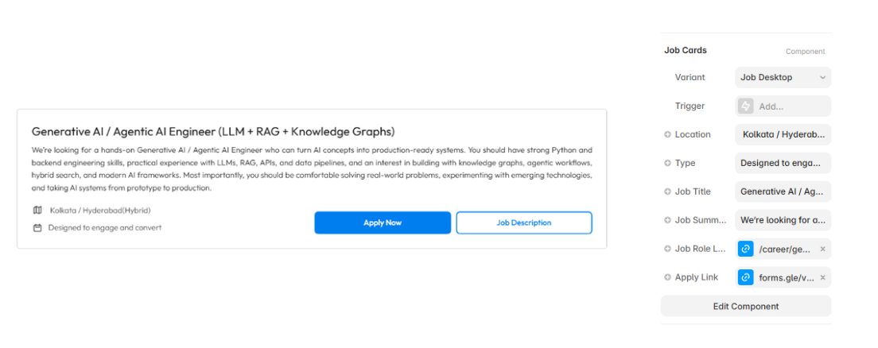Details of the job cards can be modified in the “Job Cards” section of the style panel on the right where things like Location, Type, etc can be changed according to the newly created Job Role. Link the Apply now button to the common form and the job description button to the respective job posting sub-page.

Removing a Job Posting
- Remove the job card or listing from the main “Careers” page.
- Right-click on the corresponding job posting sub-page.
- Select “Delete”.
- Publish the website to remove the job posting from the live site.
Important: Always duplicate an existing job posting page when creating a new position. This keeps the layout, design, and structure consistent across all job postings.

